Gazing upon a power station: the tourist life of energy infrastructures
Dr. Tristan LOLOUM, SNF postdoctoral fellow at Durham University (UK), Anthropology Department.

Power plants are more than mere infrastructures, they are filled with anti-utilitarian meanings and aesthetic considerations. The “Hoover Dam”, which receives more than a million visitors every year, has been labelled with many evocative names like “the Great Pyramid of the American Desert” or the “Ninth Symphony of our day” (Nye, 1994). In the 1970s, the “Architecture Plan” of EDF (Électricité de France) led by Claude Parent was meant to develop a “specific language of nuclear architecture (…): the station was not aimed to disappear, instead it had to participate in creating a new landscape” (Parent and Bouvier, 2005). Claude Parent’s architecture sketches also had suggestive titles, evocative of the symbolic power of nuclear technology: “Tutankhamun’s Feet”, “The Tiger’s Paw”, etc. There were times of nuclear enthusiasm: it was before Chernobyl, Three Mile Island and Fukushima. Tourism and leisure activities within the station were an integral part of a strategy that consisted in affirming nuclear energy as a rightful element of the territory. The nuclear utopia seems now over and many restrictions have been put to visitor access (Lopez, 2014). However, EDF still claims to be “the second most visited company in France” and is actively supporting “company visits” (another expression for “industrial tourism”) as a key tourism sector. More than ever, power stations – including wind farms and solar parks – are equipped with panoptic devices (belvederes, footbridges, etc.) and tourism facilities in order to be gazed upon, visited and admired. In this paper, tourism is considered both as a revealer of the different ideologies and values that have imbued energy architectures, and as a specific kind of place-making and knowledge producer. More than just a public relation tool for major energy corporations, tourism has become a specific way of interacting with infrastructures, raising awareness and developing a new public understanding of energy. The paper analyzes the role of tourism in the diffusion of the great “energy narratives” of the 20th century, as well as in the social construction of the current “energy transition”.

Lopez, F. (2014). Les touristes du nucléaire : l'enjeu de l'accessibilité des sites de production EDF, 1974-1991. Annales historiques de l’électricité, 12, 65-75.
Nye, D.E. (1994) American Technological Sublime, London : MIT Press.
Parent, C. and Bouvier, Y. (2005). Architecture et paysage du nucléaire : La centrale crée le site. Annales Historiques de L’électricité́, 3 (1), 7-17.

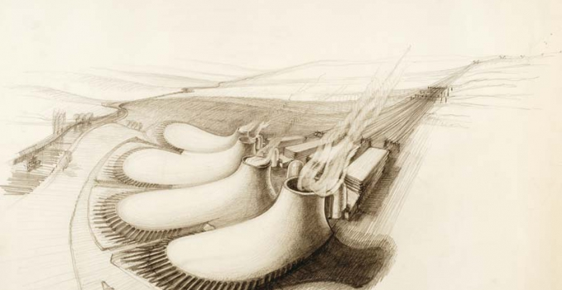
“The Tiger’s Paw”, by Claude Parent

Tristan Loloum is a social anthropologist specialized in the study of social change and tourism. He is currently working on a post-doctoral research on the “cultural politics of energy”, focusing on heritage and tourism projects involving energy infrastructures - a phenomenon sometimes referred to as “energy tourism” or “energy heritage”: electricity museums, nuclear power plants site tours and visitor centers, “coal safaris” and land art initiatives in abandoned mines, “energy trails” across wind farms or around hydroelectric dams, etc. The aim of this study is to analyze the experiential engagements of people with energy production sites, the popular aesthetics of energy and the PR strategies developed by energy corporations to make their installations meaningful to the public.

