Dreamland Alps and Tourist-Bubbles

Sliding from the sublime into picturesque worlds

“Dreamland Alps” with its fake “traditional” villages for tourists (like Andermatt Swiss Alps, constructed by the Egyptian investor Sami Sawiris just beside the real village of Andermatt), is a picturesque phenomenon based on an old desire, which began with the raise of the natural sublime in the early 18th century. At that time, the wilderness of the Alps was not anymore considered as a divine punishment (Thomas Burnet), but as part of the cosmos. The elusive vastness of the mountains provoked not only feelings of terror, but also of enthusiasm, confronting Man with the infinite, exceeding his imagination. Facing his own limits of perception, he tries to overcome himself, reconsidering everything. The sublime describes the transgression of the limit, as the etymology of the word already indicates (lat. sub-limen, up to the limit).
With the upcoming philosophical debates in aesthetics, the question of the reproduction of the sublime arose: Edmund Burke examined in 1757 the psychological effects of the sublime, trying to figure out how the different factors which generate this sensation could be reproduced, especially the infinite. Here started the interaction with architecture: Robert Barkers invention of the panorama in 1793, the first artificial “machine of the sublime”, opened up a wide range of reproductions of alpine sceneries, from the diorama to the “Swiss village”, an urban island of picturesqueness, up to the rollercoaster-Alps, a physical shock-experience in amusement parks like “Dreamland” in Coney Island.
Whereas the artificial reproduction of the sublime is quite a difficult task, the picturesque turns out to be the category of aesthetics which is most suitable for the creation of simulacra. In 1810, Sir Uvedale Price aimed to generate landscape in an artificial way “for the purpose of improving real landscape”. He announced that the picturesque, which he situates between the “maximal tension” of the sublime and the absolute “relaxation” of beauty, will become the most important category, because it “excites that active curiosity which gives play to the mind”. According to Price, the picturesque is defined by the way “how the limits are disposed”. The question of the limit is indeed a crucial one: the sensation of the sublime, generated by the vastness of Nature, is disturbed as soon as Man gets installed inside of this Nature, delimiting its infinite characteristic by architecture. Could we therefore conclude that the picturesque, due to its delimiting qualities, became the modus vivendi of architecture in the Alps, constructed for those who were longing for the sublime?
The philosophical debate in aesthetics and the boom of artificial mountain-sceneries during the 19th century stimulated different kind of interventions into the object of desire, in order to make the alpine landscape even more sublime, or more perfect and original (Viollet-le-Duc), more crystalline (Bruno Taut), more ordered (Le Corbusier), or more human (Marcel Breuer). These sort of aspirations were often linked to utopian ideas.
In the search for existential experiences, the body became in the beginning of the 20th century a major agent for the experience of the sublime, generating “maximal tension” and transgression in a physical way. Far from being an overcome phenomenon, the desire of the sublime persists until nowadays; we try to get this strong sensation by different means, becoming more and more extreme. Architecture as well can act as an “operator of the sublime”, confronting us with our limits by very specific spatial devices (like huge cantilevers over precipices generating vertigo, or completely isolated transparent bubbles in the middle of the mountains, etc.).
Somewhere in the large gap between the desire of the sublime and the modus vivendi of the picturesque, is situated the alpine architecture, created for tourists. A more precise analysis about the nature of our desires and the constructed realities, often quite deceiving, could be inspiring in order to reconsider the future constructions of “tourist-bubbles” – maybe in a much more radical and efficient way?

Susanne Stacher
Docteur en architecture et aménagement

Architecte et enseignante-chercheur titulaire
Théorie et pratique architecturale et urbaine
École Nationale Supérieure d'Architecture de Versailles

24, rue Vieille du Temple, 75004 PARIS, +33 6/84 00 79 34 susannestacher@hotmail.com

Biography

Susanne Stacher is an architect and critique of architecture. She teaches as a Research Associate Professor at the National architecture school of Versailles (ENSA-V). After having worked in several international architecture offices in France and Switzerland, she orientates herself more and more towards research and teaching, starting at the ETH in Zürich in 1999. In September 2016 she submits her PHD with the topic: Dreamland Alps, alpine Architecture in the Prism of the Sublime (with the distinctions of the jury), in a bilateral cooperation between the ENSA-V and the University of Applied Arts in Vienna, under the direction of Philippe Potié and Matthias Boeckl. Her research field is situated between architecture, urbanism, theory and philosophy.

Images

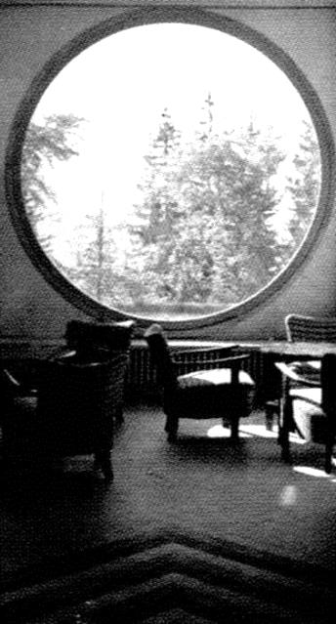 | 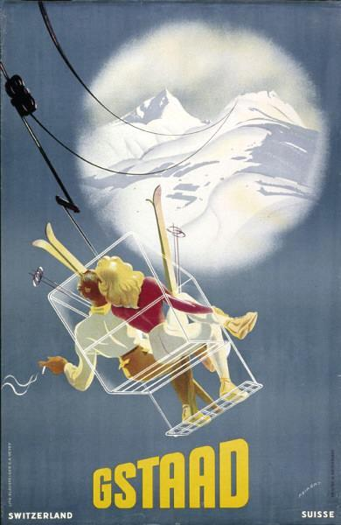 | 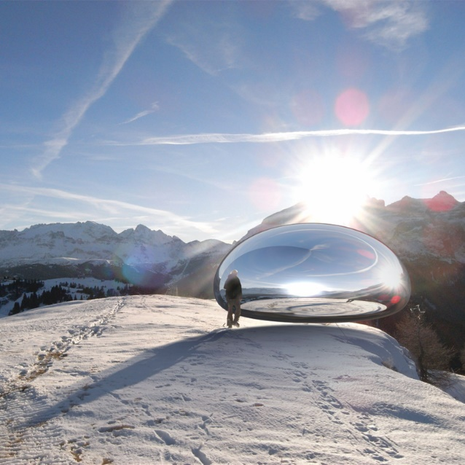
View outside from a sanatorium, Plateau d’Assy, France, 1930ies  Architecture | Publicity for Gstad, Switzerland,1950ies  Fiction | Alpine Capsule by Ross Lovegrove, Dolomites, project 2008  Virtual reality

Endnotes

Edmund Burke, A philosophical Enquiry into the Origin of our Idea of the Sublime and the Beautiful, Ed. R. and J. Dodsley, London, 1757, S. 77: “Another source of sublime is infinity: if it does not rather belong to the last. Infinity has a tendency to fill the mind with that sort of delightful horror, which is the most genuine effect, and truest test of the sublime.”
Sir Uvedale Price, Essays on the picturesque, as compared with the sublime and the beautiful: and, on the use of studying pictures, for the purpose of improving real landscape, Vol. 1, London, 1810, Printed for J. Mawman, 22 Poultry, 1810, p. 84: “[…] the sublime […], being founded on ideas of pain and terror, […] operates by stretching the fibres beyond their natural tone. [Beauty] acts by relaxing the fibres somewhat below their natural tone, and this is accompanied by an inward sense of melting and languor. […] picturesqueness when mixed with either of the other characters, corrects the languor of beauty, or the tension of sublimity.”
Idem, p. 89: “It is the coquetry of nature; it makes it beauty more amusing, more varied, more playful, but also ›less winning soft, less amiably mild‹. Again, by its variety, its partial concealments, it excites that active curiosity which gives play to the mind, loosening those iron bonds, with which astonishment chains up its faculties.”
See: Susanne Stacher, Dreamland Alps. Alpine architecture in the prism of the sublime, PHD, Versailles-Vienna, 2016.

